# Information Security

# Project Report

# Title: Academic Application Tracker

Members: 19K-1057 Muhammad Khizer Jilani

19K-1116 Sarmad Jamal

19K-1114 Mansoor Butt

Section: SE-A

Submitted to: Fahad Samad

Dated: 10-Dec-2022

# Overview

In this project we have made an academic Application Tracker. The System allows the student of a University to upload his/her application related to any University Issue as soon as the student uploads the application on our portal the application is stored on the IPFS. IPFS is a distributed peer to peer file system just like torrent. As the application is uploaded on the IPFS, it will generate a unique hash, this hash will be stored on our Smart Contract, the Smart Contract will be deployed on a blockchain network. The reason to use Smart Contracts and Blockchain in this project is to make our System more Secure, also to allow a Consensus Mechanism which will be implemented in the later process.

The other concept we are using is RBAC, where Teacher, HOD and Director will have a separate portal and all of them will have the access of the same application uploaded by the student. All 3 stakeholders’ approvals are required to approve the application depending on the nature of application means how critical it is.

All the stakeholders have their own digital signatures, this feature will ensure that no unauthorized entity can access the application or perform any kind of operations which are not authorized for it to perform.

# Role Based Access Control

## Step 1:

we are using Ganache which is a software which provides a test RPC, the RPC is connected to Ganache’s locally deployed blockchain network also it provides us with 10 registered addresses along with their private keys. We are using the first three accounts addresses which will be assigned to the Professors and HOD

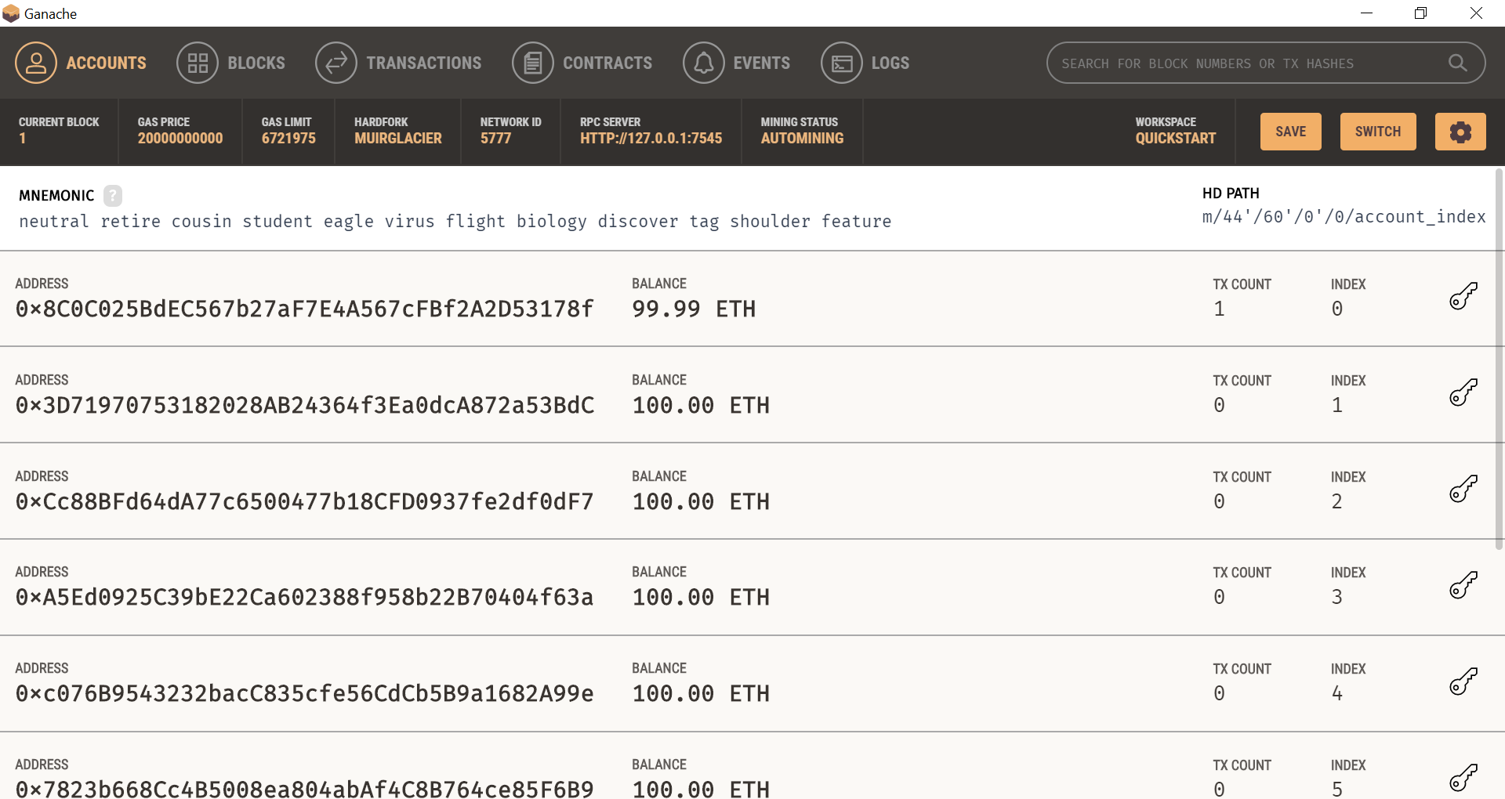

Portal



## Step 2

We are authenticating login accounts with MetaMask. MeteMask is a digital wallet which provides every user with their custom private keys and hash addresses

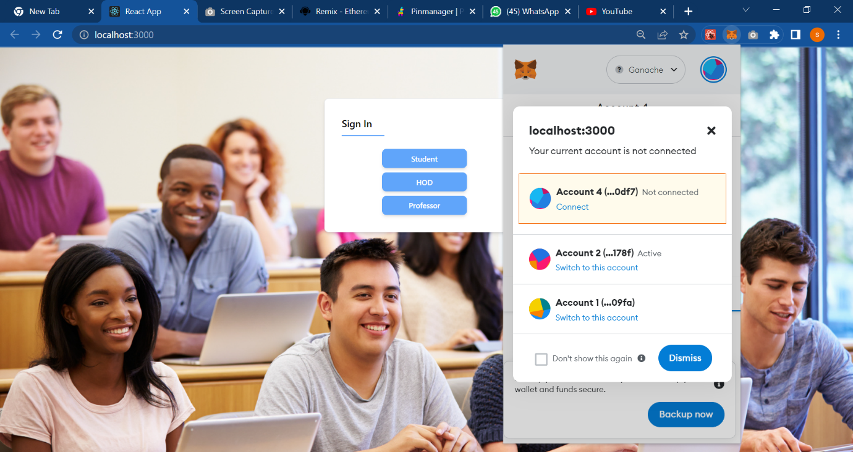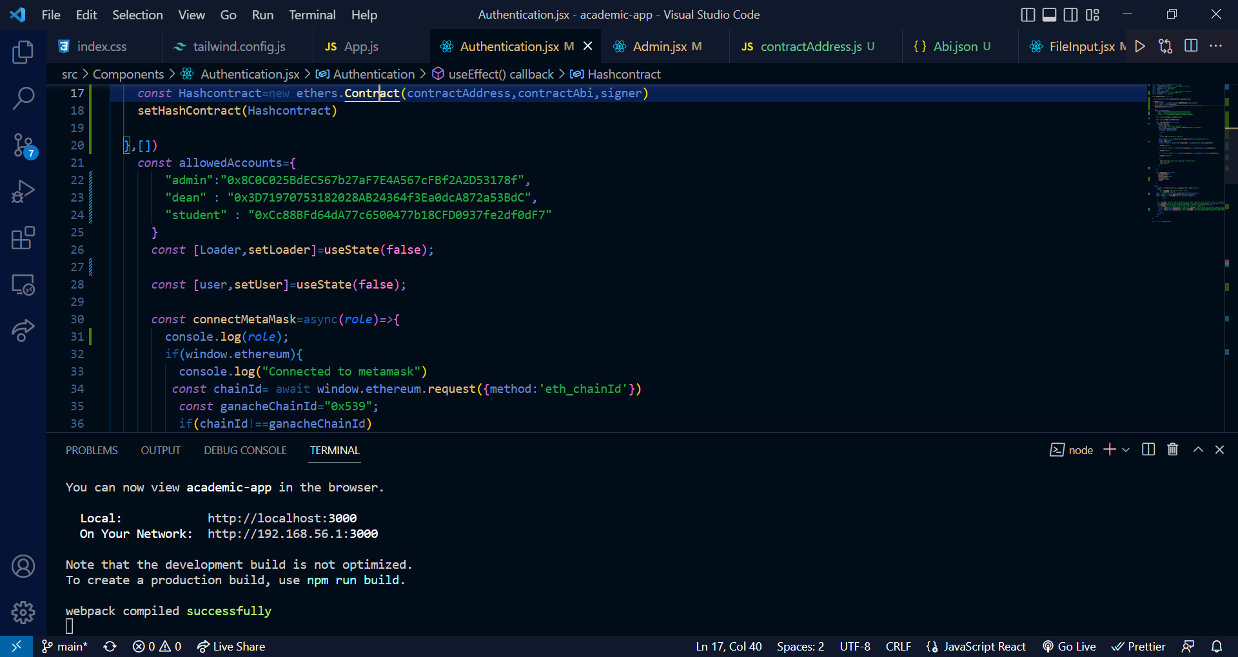

## Step 3:

Student logins via the portal the MetaMask verifies the student by communicating with the smart contract

## Step 4:

Student uploads the application on the portal 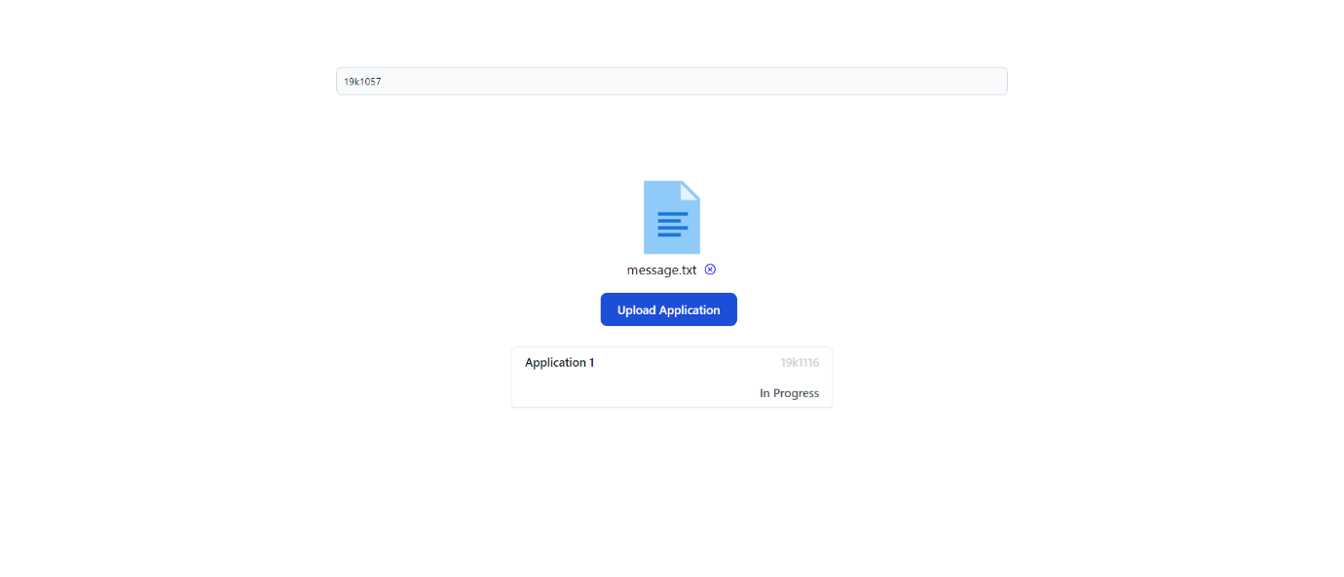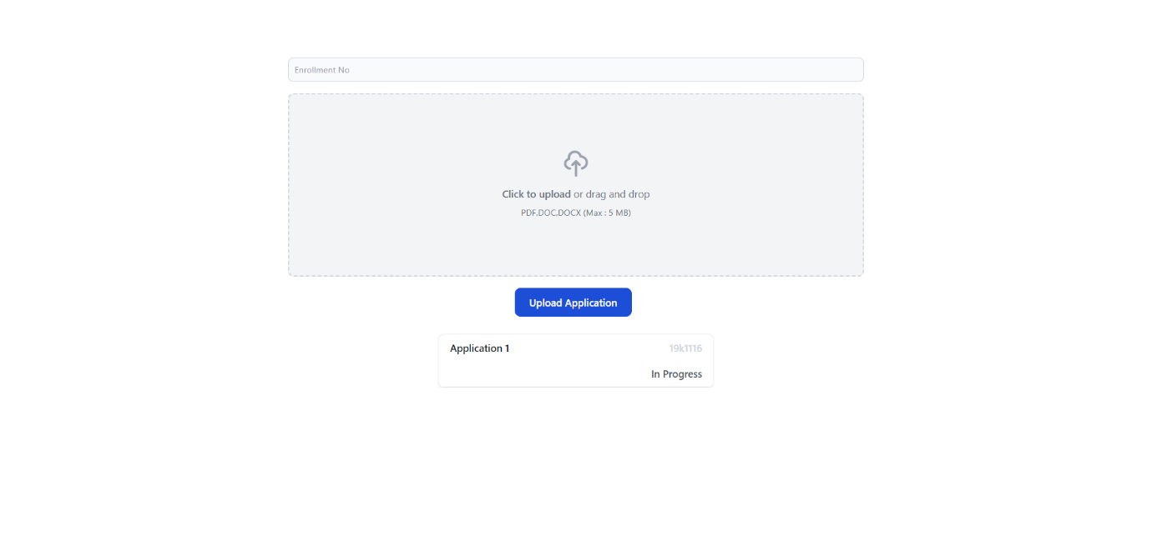

## Step 5:

The Application will be stored on Pinata which is an IPFS hosting platform also we can access hash of that Application 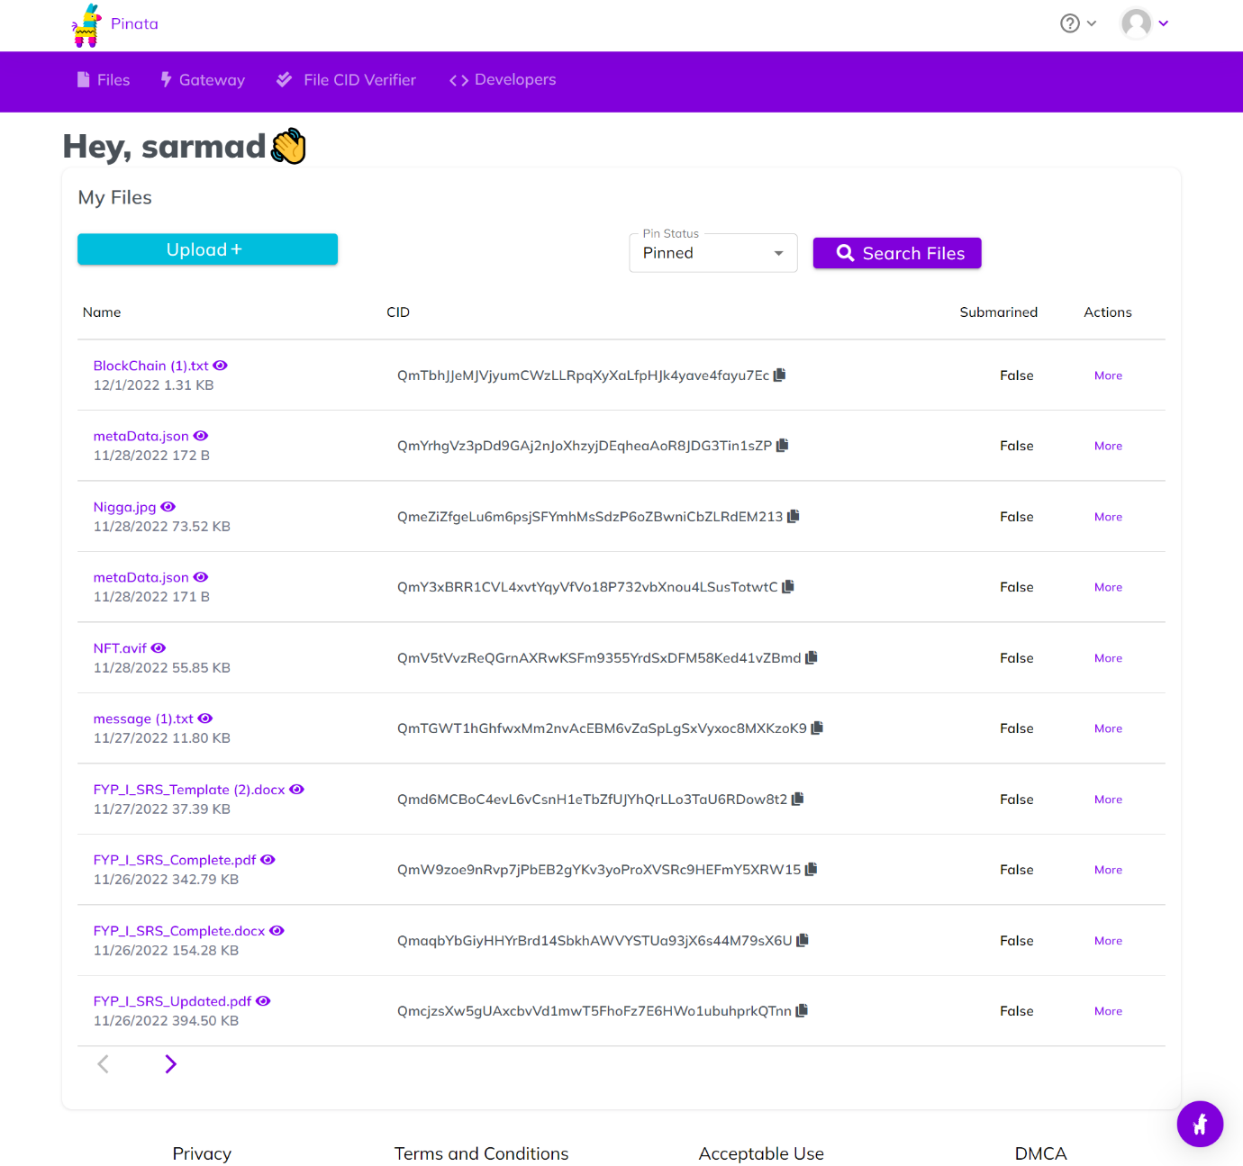

## Step 6:

Now the Application will be available to be viewed for all stakeholders including Professors and HOD on their relevant portal.

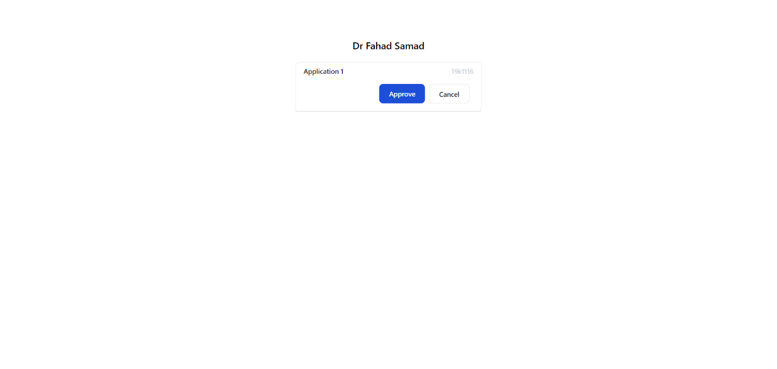

Now the Professor Doctor Fahad Samad will view the application by clicking on the tag Application 1 and the file will be downloaded

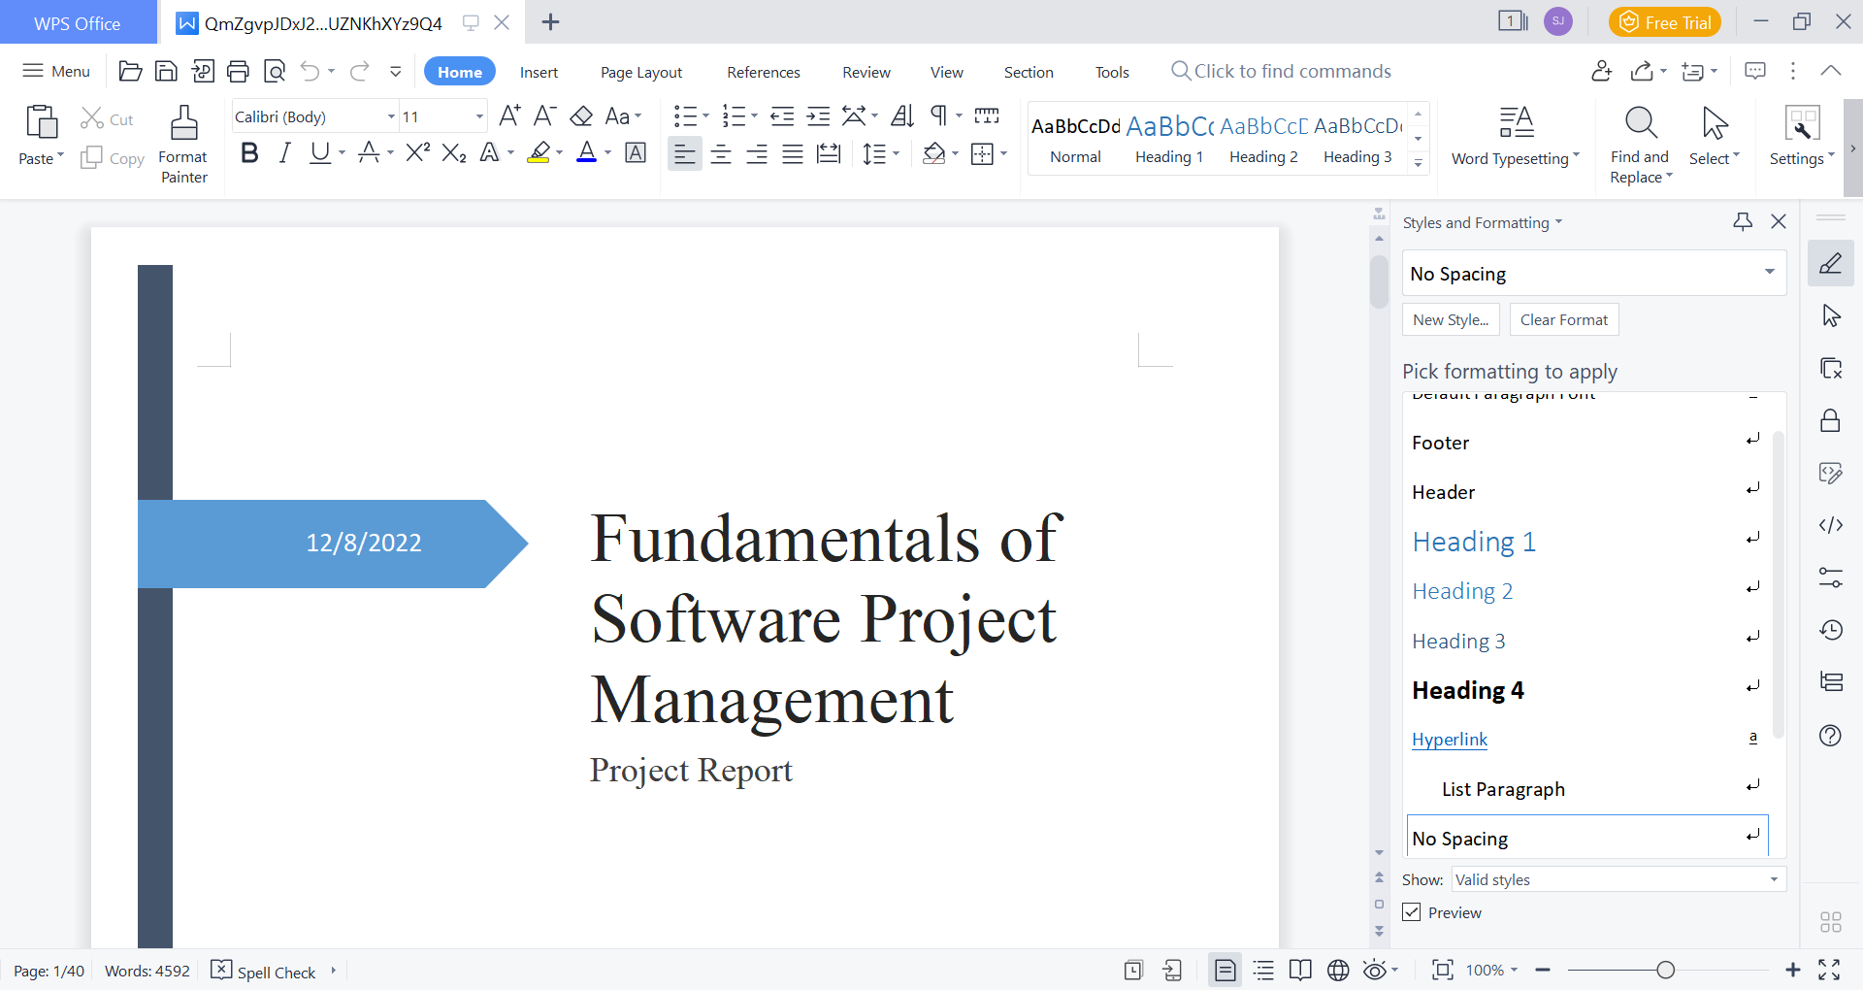

For instance, we have uploaded this document from student profile and the file is now downloaded and can be viewed

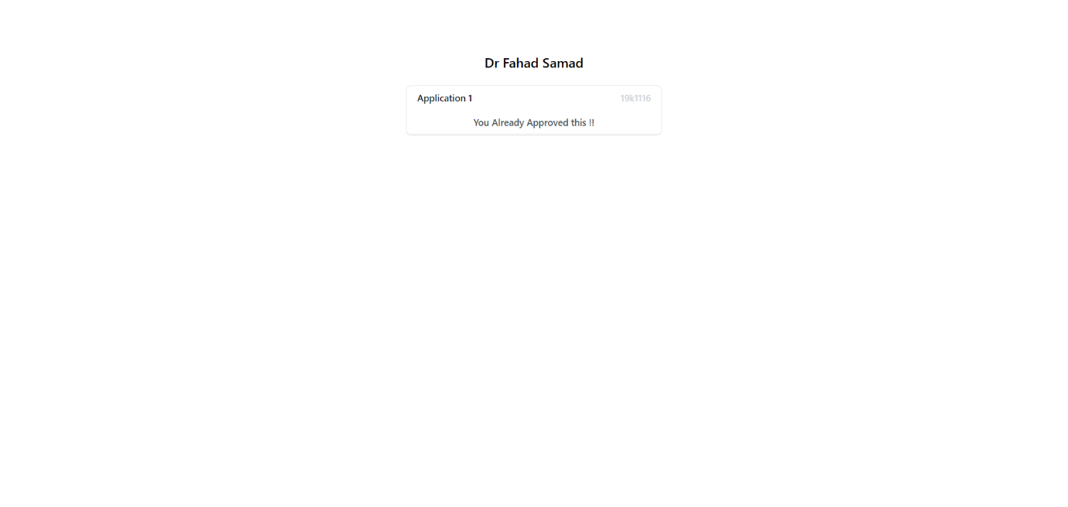

Dr Fahad Samad approved this application as we can see

## Step 7:

Now all the stakeholders will either approve or reject the application, the application will only be accepted if all the stakeholders approve it else it will be rejected

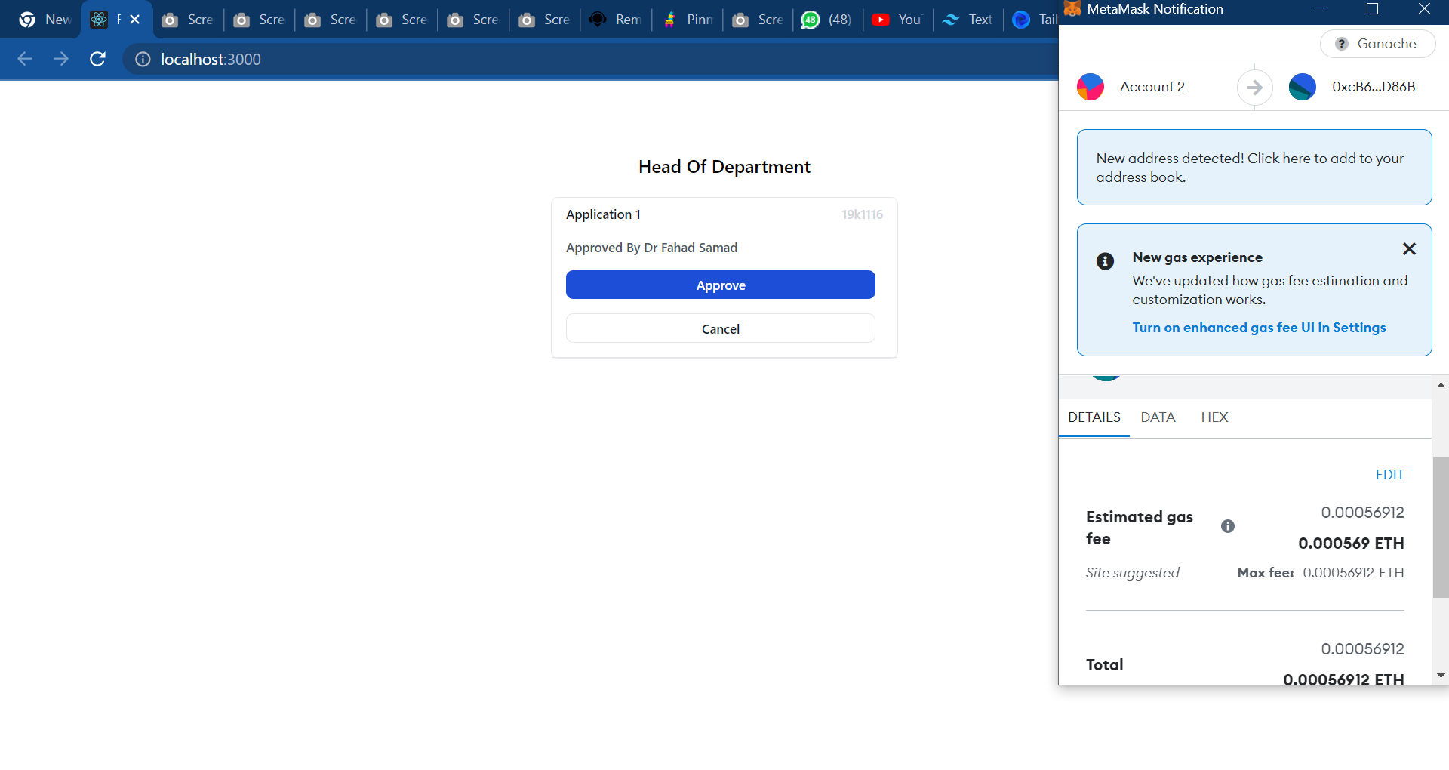

## Step 8:

The student on its portal can track the status of the application that whether It was accepted or rejected.

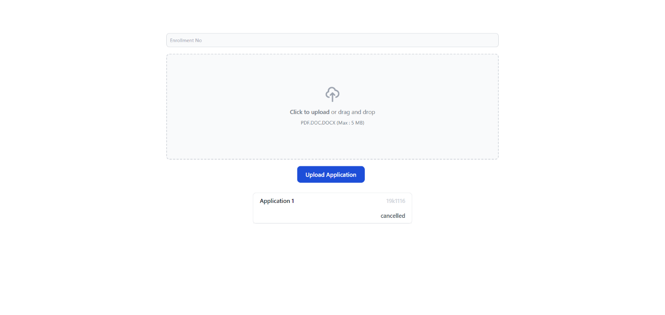

# Digital Signature

Here we are encrypting our digital account with MetaMask private key to ensure strong security mechanism every individual user get its private key via MetaMask which ensures the authentication helps in creating the digital signature of individual User so this mechanism ensures that sender can’t set stance of denial on sent message.

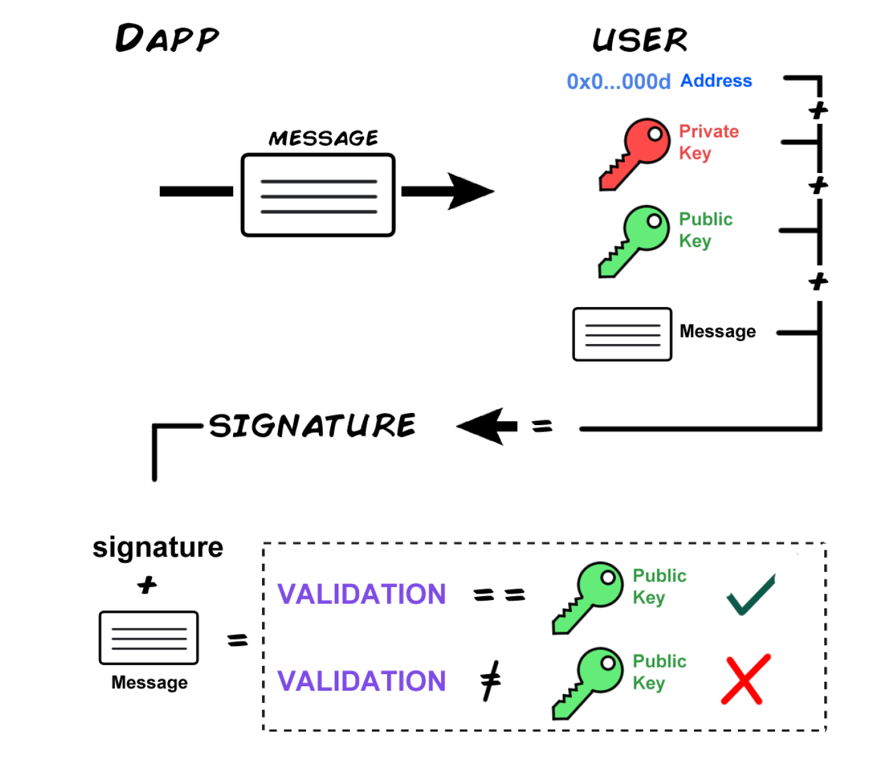

For instance as define in this picture we are taking private key of user and a message which we are sending to our smart contract and it is returning a public key and we are comparing MetaMask public address of the user account with the return value if this condition satisfies we are allowing user to approve and cancel our application

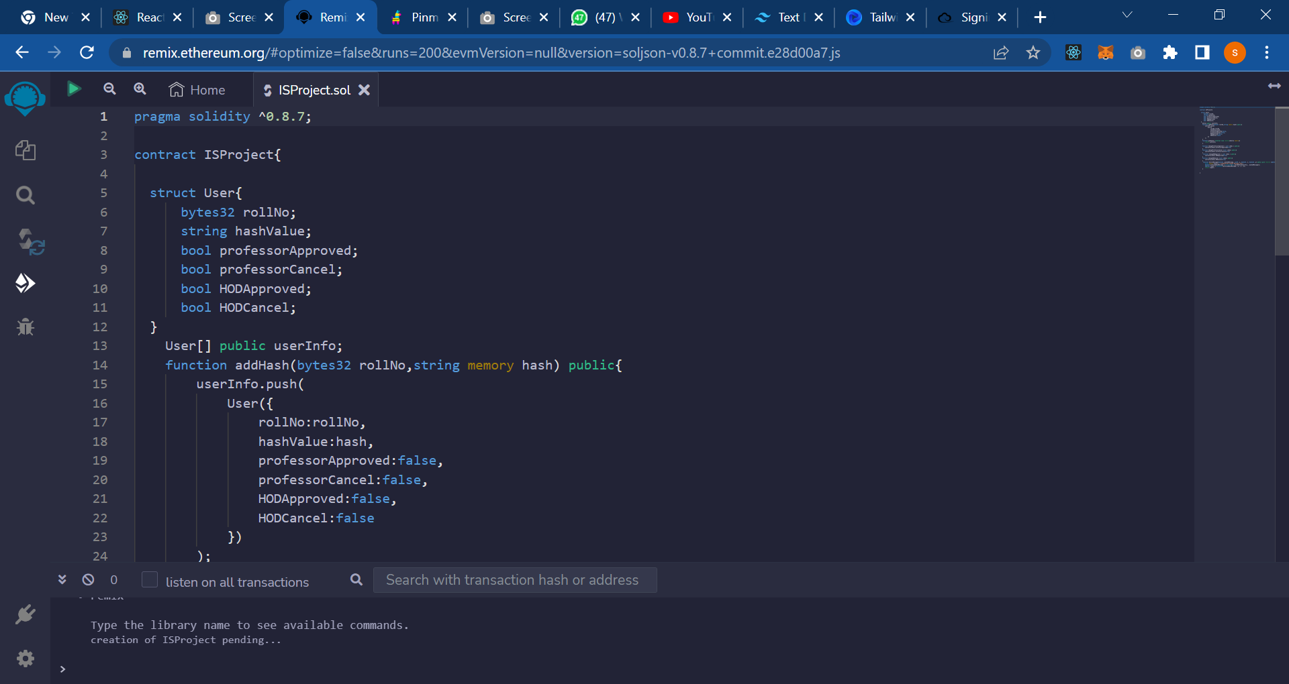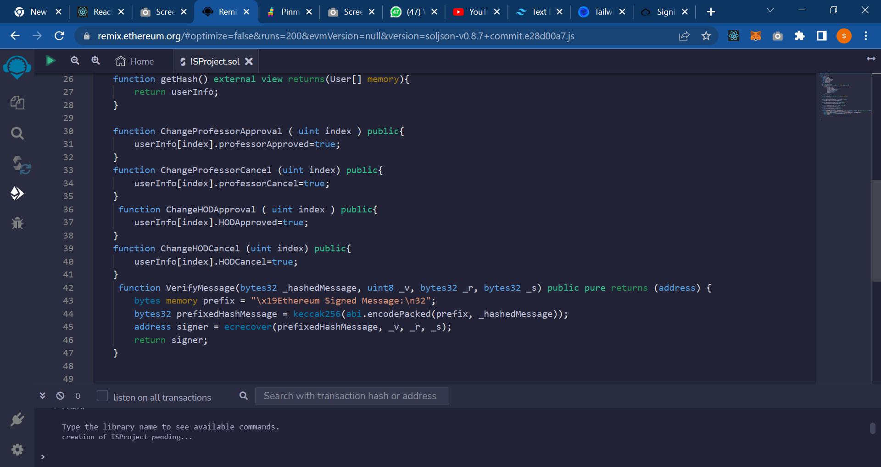

# Acronyms

IPFS = interplanetary File System

RBAC = Role Based Access Control

HOD = Head of Department

RPC = Remote Procedure Call